

Tribhuvan University
Faculty of Humanities and Social Sciences

Smart Tourism Navigation and Bus Management System

A PROJECT PROPOSAL

Submitted to
Department of Computer Application
D.A.V. College

In partial fulfillment of the requirements for the Bachelors in Computer Application

Submitted by
Avash Khadka
TU Reg No: 6-2-469-11-2024
June, 2026

Table of Contents
TABLE OF CONTENTS i
LIST OF FIGURES ii
CHAPTER 1: INTRODUCTION 1
CHAPTER 2: PROBLEM STATEMENT 2
CHAPTER 3: OBJECTIVES 3
CHAPTER 4: METHODOLOGY 4
4.1 Requirement Identification 5
4.1.1 Study of Existing System 5
4.1.2 Requirement Collection 6
4.2 Feasibility Study 7
4.2.1 Technical Feasibility 7
4.2.2 Operational Feasibility 7
4.2.3 Economic Feasibility 7
4.3 High level Design of System 8
CHAPTER 5: GANTT CHART 14
CHAPTER 6: EXPECTED OUTCOME 15
Chapter 7: References 17

LIST OF FIGURES
Figure 4.1: Waterfall Model of SDLC 4
Figure 4.2: ER Diagram of Smart Tourism and Bus Management System 8
Figure 4.3: Use Case Diagram of Smart Tourism and Bus Management System 9
Figure 4.4: Flow Chart of Smart Tourism and Bus Management System 11
Figure 4.5: Context Diagram of Smart Tourism and Bus Management System 12
Figure 4.6: Level DFD of Smart Tourism and Bus Management System 12
Figure 4.7: System Architecture Tourism and Bus Management System 13
Figure 5.1: Gantt Chart of Smart Tourism and Bus Management System 14
Figure 6.1: Login Page 15
Figure 6.2: User’s Dashboard 16
Figure 6.3: Discover Page 16

CHAPTER 1: INTRODUCTION
The rapid growth of urban transportation systems and digital mapping technologies has created opportunities for smarter and more connected travel experiences. People frequently face difficulties in finding reliable bus routes, tracking buses in real time, discovering useful nearby locations, and sharing local route information with others. Existing systems often focus only on tourism, ride-hailing, or static transport schedules, leaving a gap for a community-driven navigation and bus management platform.
The proposed project, KHOJA: Smart Tourism Navigation and Bus Management System, aims to address these challenges by combining real-time bus tracking, interactive route navigation, community location sharing, and role-based management portals for users, drivers, and administrators.
The system is designed as a modern web platform where, users can explore nearby places, view live buses on a map, and book transportation, drivers can register buses, create routes visually on a map, and manage trips, Administrators can moderate community contributions, manage buses and drivers, and monitor system analytics.
By integrating geolocation, mapping services, community contributions, and transport management into a single platform, KHOJA provides a smarter and more collaborative navigation ecosystem for everyday users, not just tourists.

CHAPTER 2: PROBLEM STATEMENT
The current transportation and navigation ecosystem faces several challenges that reduce efficiency and convenience for users. One of the major issues is the lack of real-time visibility of public transport, as commuters often have no accurate information about the current location of buses or their expected arrival times. Additionally, navigation services, bus tracking systems, route-sharing platforms, and booking applications are typically developed as separate solutions, resulting in a fragmented user experience. Existing systems also provide limited opportunities for community participation, preventing users from contributing valuable local information such as newly established bus stops, road conditions, or important community locations.
Furthermore, drivers and transport operators often lack intuitive tools for creating, managing, and updating routes visually. Many local transportation platforms also suffer from outdated interfaces, incomplete information, and poor mobile responsiveness, leading to an unsatisfactory user experience. These limitations contribute to commuter inconvenience, inefficient transport coordination, and the underutilization of community-generated geographic information, highlighting the need for an integrated and user-friendly transportation and tourism mapping solution.

CHAPTER 3: OBJECTIVES
The main objective of the project is to develop a modern, community-driven navigation and bus management platform that improves public transport accessibility and local route sharing.
- To develop a smart transportation management platform that improves accessibility, efficiency, and reliability of public bus services through digital navigation and route management.
- To provide an interactive and location-based system that helps users discover nearby places, find suitable bus routes, and access real-time transportation information.
- To create a collaborative platform that enables passengers, drivers, and administrators to efficiently share information, manage transportation services, and enhance overall travel experience.

CHAPTER 4: METHODOLOGY
Development of the Smart Tourism Navigation and Bus Management System will follow the Waterfall Model of the Software Development Life Cycle (SDLC). The Waterfall Model is a linear and sequential model of software development. In this model, each phase of the SDLC which includes: Planning, Analysis, Design, Development and Implementation, must be completed before moving onto the next phase and returning to a previous phase is not recommended.
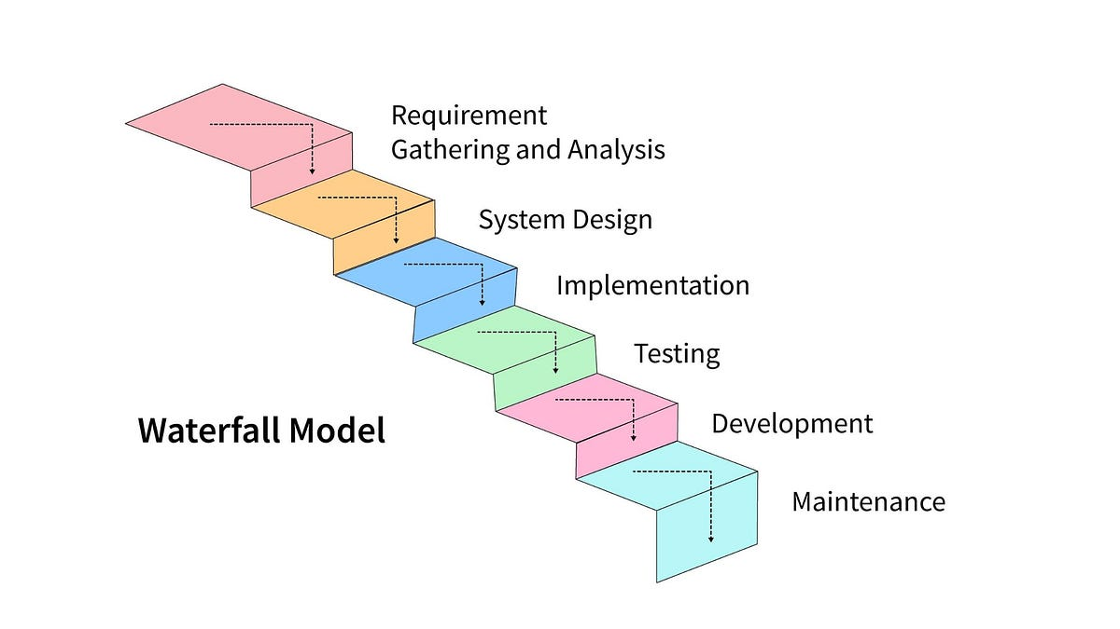
Figure 4.1: Waterfall Model of SDLC
This methodology is suitable for developing the Smart Tourism Navigation and Bus Management System as the requirements, features, and roles in this system are fixed and clearly defined from the beginning. The Waterfall Model also provides a systematic and structured approach to software development, which allows for proper planning, clear documentation, and better scheduling of the entire project.
Another important advantage of this model is that it supports better project planning and estimation. Because the requirements of the system are already known, it becomes easier to define timelines, allocate resources, and manage tasks efficiently. This makes the development process more organized and predictable.

4.1 Requirement Identification

4.1.1 Study of Existing System
Before designing the proposed Smart Tourism Navigation and Bus Management System, several existing platforms such as Google Maps, Uber, TripAdvisor were studied. The purpose of this analysis was to understand how current systems handle navigation, transport management, tourism services, and user interaction.
The study mainly focused on the following aspects:
- Navigation and route planning features.
- Real-time location tracking and updates.
- User contribution and feedback systems.
- Ride or transport management interfaces.
- Tourism information integration.
- Mobile responsiveness and overall UI/UX design.
Google Maps
Google Maps is a web-based and mobile navigation service developed by Google that provides detailed geographical information, GPS-based navigation, and location-based services [4]. It is widely used for route planning, traffic monitoring, and exploring nearby places such as restaurants, hospitals, and tourist destinations. The platform offers features including real-time GPS navigation, multiple transportation modes (car, walking, cycling, and public transport), live traffic updates, alternative route suggestions, satellite and street views, ETA calculation, distance measurement, location sharing, and saving favorite places.
However, Google Maps has limitations for specialized local transportation systems, as it provides limited support for community-based transport information, does not include dedicated bus route creation and management tools, offers basic tourism integration, depends heavily on internet connectivity for full functionality, and lacks direct integration with local transport operators.
TripAdvisor
Tripadvisor is a tourism and travel platform that provides information about hotels, restaurants, attractions, and travel destinations. It mainly focuses on user-generated reviews, ratings, and travel experiences to help users make informed decisions while planning trips [1]. The platform provides features such as hotel and restaurant listings, attraction recommendations, user reviews and feedback, booking options for accommodations and experiences, destination photos, and tourism-focused search and discovery tools.
However, Tripadvisor has limitations in transportation-related services, as it does not provide real-time navigation or GPS tracking, does not support bus tracking or route management systems, and lacks route optimization and live travel updates. Additionally, review-based information may sometimes be subjective or biased, and its integration with local transportation services is limited.

4.1.2 Requirement Collection
Functional Requirements
S.N. | Requirement | Description
1 | User Registration and Authentication | The system allows users to create accounts and securely log in using their personal information.
2 | Location Detection using GPS | The system uses GPS to identify the user's current location accurately. It helps provide location-based services such as nearby places and available routes.
3 | Nearby Place Discovery | The system allows users to find nearby tourist attractions based on their location. It provides details such as descriptions, images, opening hours, and entry fees of places.
4 | Real-Time Bus Tracking | The system tracks buses using GPS data updated by drivers. Users can view current bus locations, routes, and estimated arrival information.
5 | Community Location Contribution and Reporting | Users can submit requests for adding new tourist places or reporting incorrect information. Administrators review these requests before updating the system database.
6 | Driver Bus Registration and Route Creation | Drivers can register buses and provide necessary bus information in the system. They can create routes and update details such as distance, destination, and travel time.
Table 4.1: Functional Requirements of the system

Non-Functional Requirements
- Responsive design for mobile and desktop.
- Fast map rendering and route updates.
- Secure authentication and role management.
- Scalable database structure.
- Easy-to-use interface with modern UI/UX principles.

4.2 Feasibility Study

4.2.1 Technical Feasibility
The project is technically feasible because the required technologies are widely available and well-supported. The system is built using modern and reliable tools that are commonly used in web development. The frontend technologies include HTML, CSS, JavaScript. The backend is developed using PHP and Java, while MySQL is used as the database management system. For mapping functionality, Leaflet.js combined with OpenStreetMap is used, and real-time updates are handled through AJAX polling and WebSockets. Additionally, modern web browsers already support essential features like geolocation APIs, interactive maps, and responsive design, making the overall implementation practical within the project scope [2] [3].

4.2.2 Operational Feasibility
The system is operationally feasible because it is designed to be simple and user-friendly for all types of users. Users interact with the system through an intuitive map-based interface, which makes navigation easy and familiar. Drivers can manage and update routes visually without requiring advanced technical knowledge. Administrators are provided with a dashboard that supports moderation, monitoring, and basic analytics. Since the interface follows patterns similar to popular navigation applications, minimal training is required for users to effectively operate the system.

4.2.3 Economic Feasibility
The project is economically feasible because it relies mainly on open-source technologies, which significantly reduces development and operational costs. Tools such as OpenStreetMap and Leaflet.js are free to use, eliminating licensing expenses. Similarly, open-source backend frameworks and database systems further reduce cost requirements. In addition, the system can be deployed on low-cost cloud services or shared hosting platforms during its initial phase. As a result, the overall implementation remains affordable and suitable for academic and prototype-level development.

4.3 High level Design of System
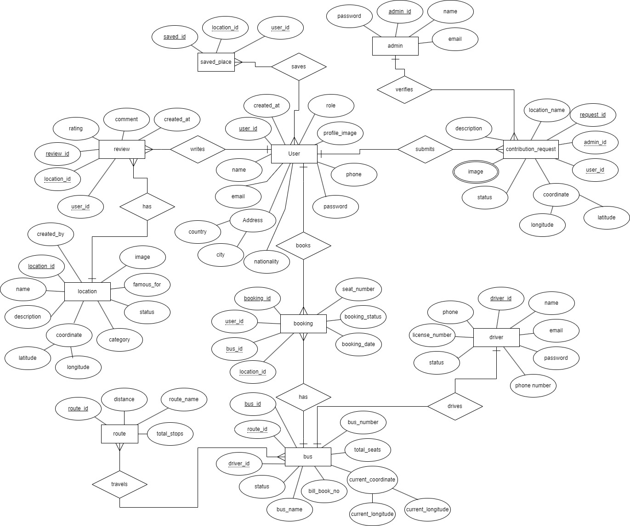
Figure 4.2: ER Diagram of Smart Tourism and Bus Management System
The ER diagram is designed around the User entity, which connects most system activities. Users can explore locations, save places, provide reviews, request new locations, and book buses. Admin manages system reliability by verifying contributions and controlling users, routes, buses, and locations. Drivers are responsible for bus operations and live tracking, while routes and buses support transportation services.
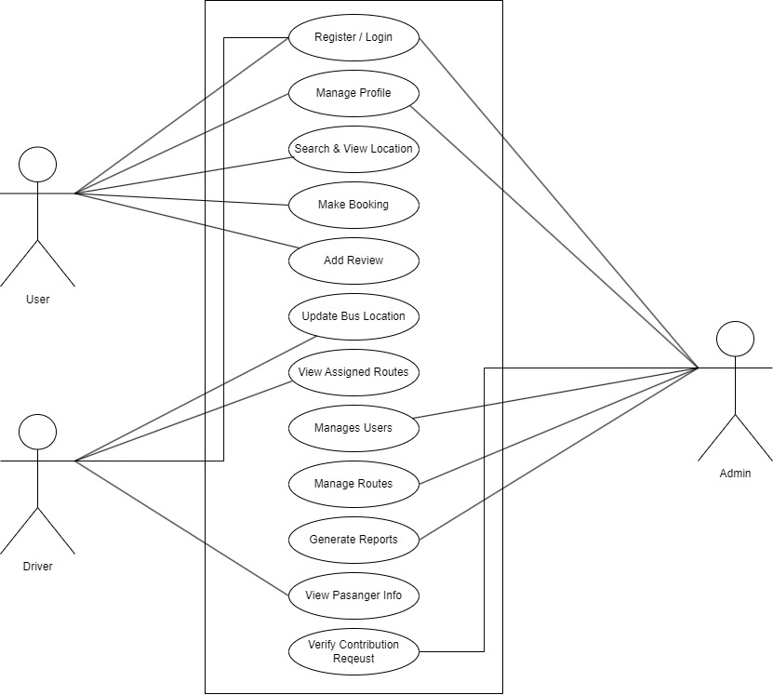
Figure 4.3: Use Case Diagram of Smart Tourism and Bus Management System
The system provides separate functionality based on user roles. Normal users mainly focus on tourism exploration and booking services, drivers handle transportation operations, and administrators manage security, verification, and overall system maintenance. The use case diagram ensures that each actor has clearly defined responsibilities and access permissions.
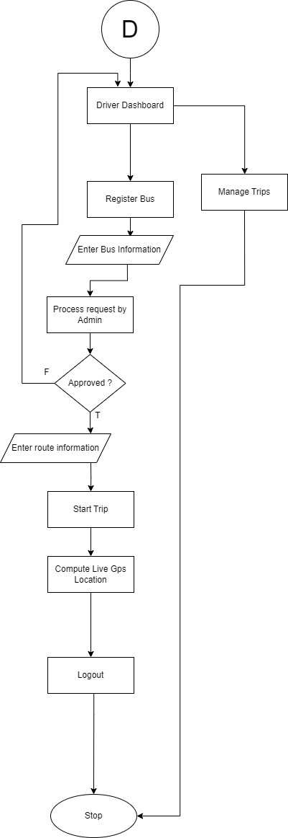
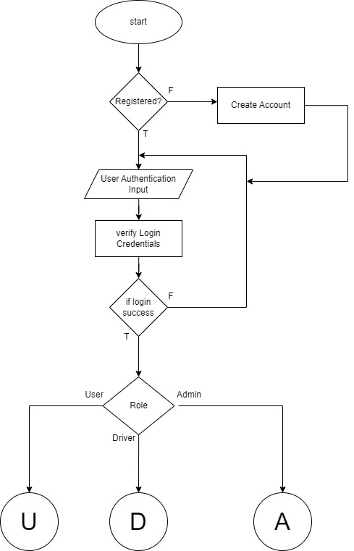

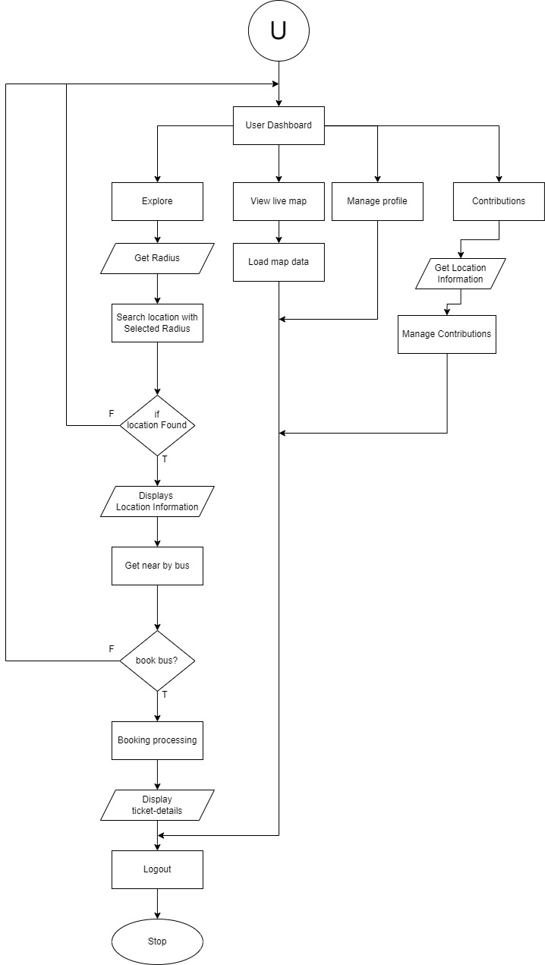

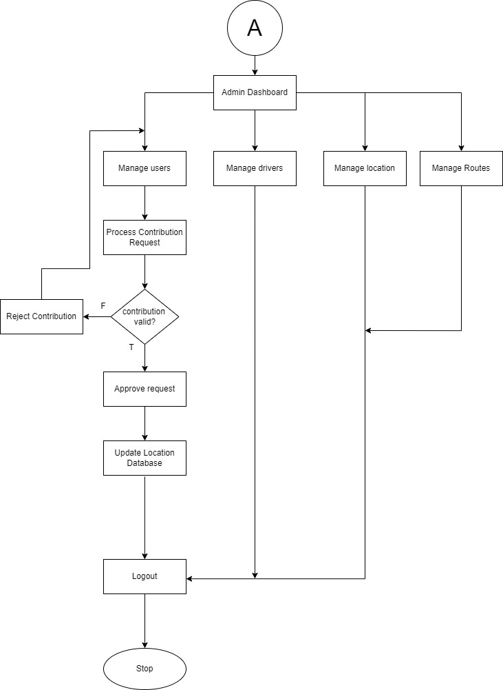

Figure 4.4: Flow Chart of Smart Tourism and Bus Management System
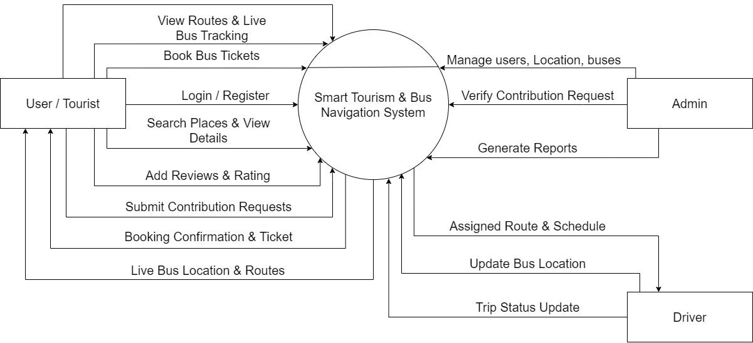
The complete system follows a role-based workflow. After authentication, users are redirected according to their roles. Users mainly interact with tourism search and booking features, drivers manage transportation and live tracking, while administrators maintain system security, data accuracy, and overall management. The flow ensures smooth communication between users, drivers, bes, locations, and administrators.
Figure 4.5: Context Diagram of Smart Tourism and Bus Management System
This diagram provides a high-level overview of the Smart Tourism & Bus Navigation System. It illustrates the primary interactions between the central system and external entities such as Users/Tourists, Admin, and Drivers. Users can perform actions like booking tickets, viewing routes, and submitting reviews. The Admin manages system content, users, and verifies contributions. Drivers update bus locations and trip statuses, ensuring real-time information flow.
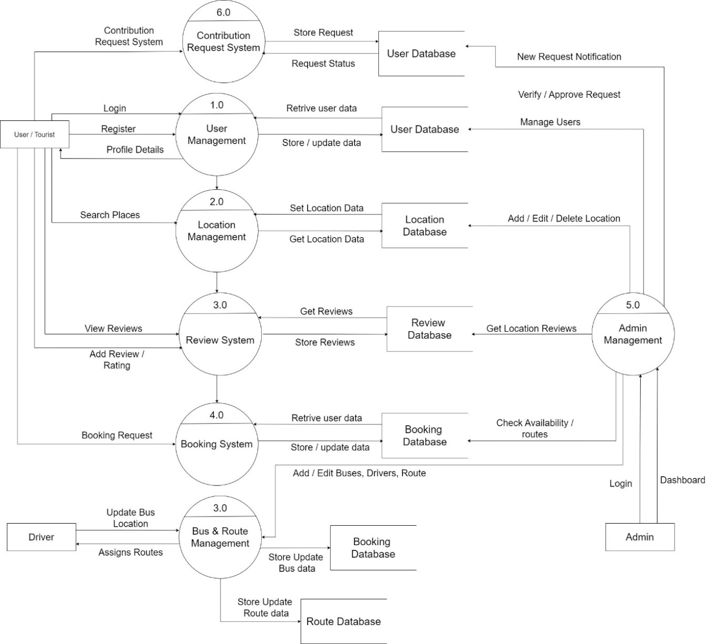

Figure 4.6: Level DFD of Smart Tourism and Bus Management System
This detailed diagram breaks down the Smart Tourism & Bus Navigation System into six interconnected sub-processes. These include User Management, Location Management, Review System, Booking System, Admin Management, and Contribution Request System. Each process interacts with specific databases like User, Location, Review, Booking, and Route Databases to store and retrieve information. Admin Management oversees various functionalities, including user management and approving contribution requests.
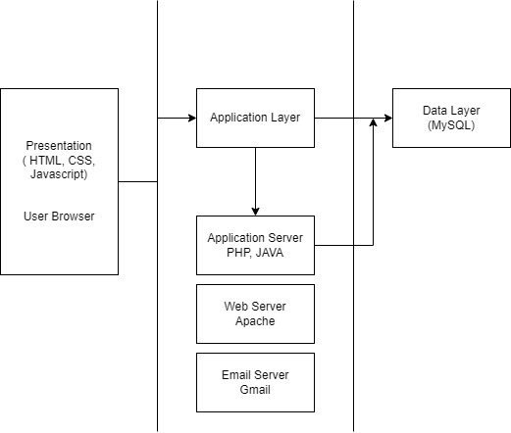
Figure 4.7: System Architecture
This diagram showcases the three-layered architecture of the Smart Tourism & Bus Management System: Presentation, Application, and Data. The Presentation layer, comprising HTML, CSS, and JavaScript, is responsible for the user interface displayed in the browser. The Application layer, built with PHP and hosted on an Apache Web Server, handles the core business logic and interactions. It also integrates an Email Server (Gmail) for communication purposes. The Data layer uses MySQL as the relational database management system to store all persistent information. Data flows between these layers, from user interaction through application processing to database storage and retrieval.

CHAPTER 5: GANTT CHART 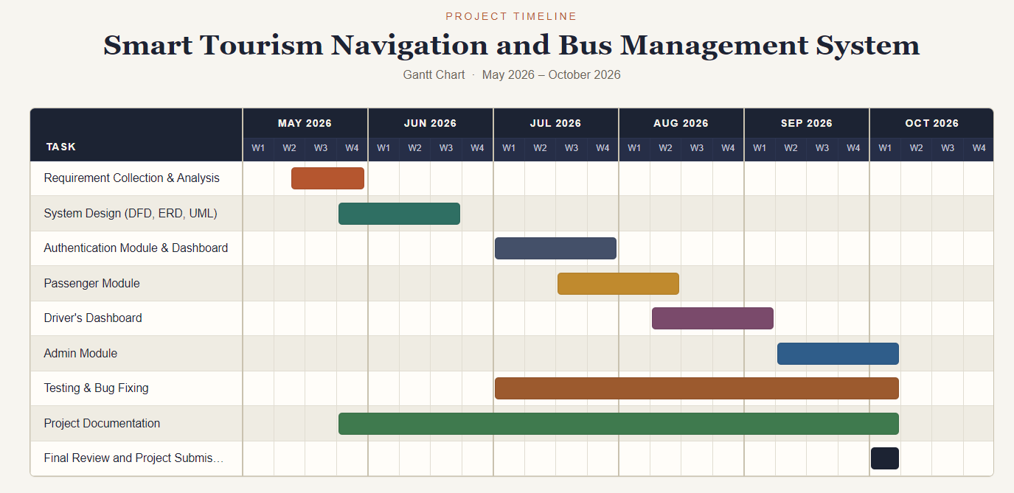
Figure 5.1 Gantt Chart of Smart Tourism and Bus Management System
This Gantt chart visually represents the "Smart Tourism Navigation and Bus Management System" project timeline from May to October 2026. Key project phases such as Requirement Collection, System Design, and Module Development (Authentication, Passenger, Driver, Admin) are clearly outlined. Testing & Bug Fixing and Project Documentation are shown as ongoing activities throughout several months, highlighting their continuous nature. The chart concludes with a final review and project submission in October, marking the project's completion. Each task's duration is visually depicted by colored bars, offering a clear schedule of work.

CHAPTER 6: EXPECTED OUTCOME
The project is expected to deliver:
- A fully functional web-based navigation and bus management platform.
- Real-time bus tracking on interactive maps.
- GPS-based nearby location discovery.
- Community-driven location sharing and reporting.
- Role-based dashboards for users, drivers, and administrators.
- A visual route creation system using map interactions.
- A modern, responsive, and user-friendly interface.
Benefits of the System
- Improved public transport visibility and convenience.
- Faster route planning and navigation.
- Enhanced community participation in local mapping.
- Better route management for drivers and transport operators.
- A scalable foundation for future smart-city features such as traffic alerts, occupancy prediction, and mobile applications.

- Login Page
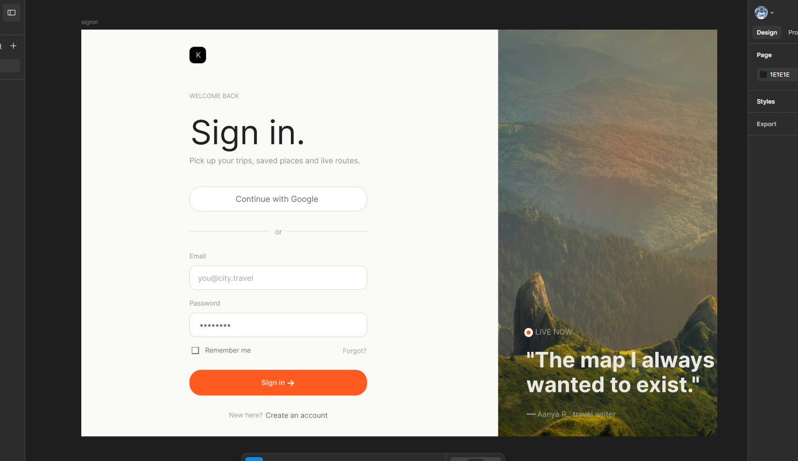
Figure 6.1: Login Page

- User’s Dashboard
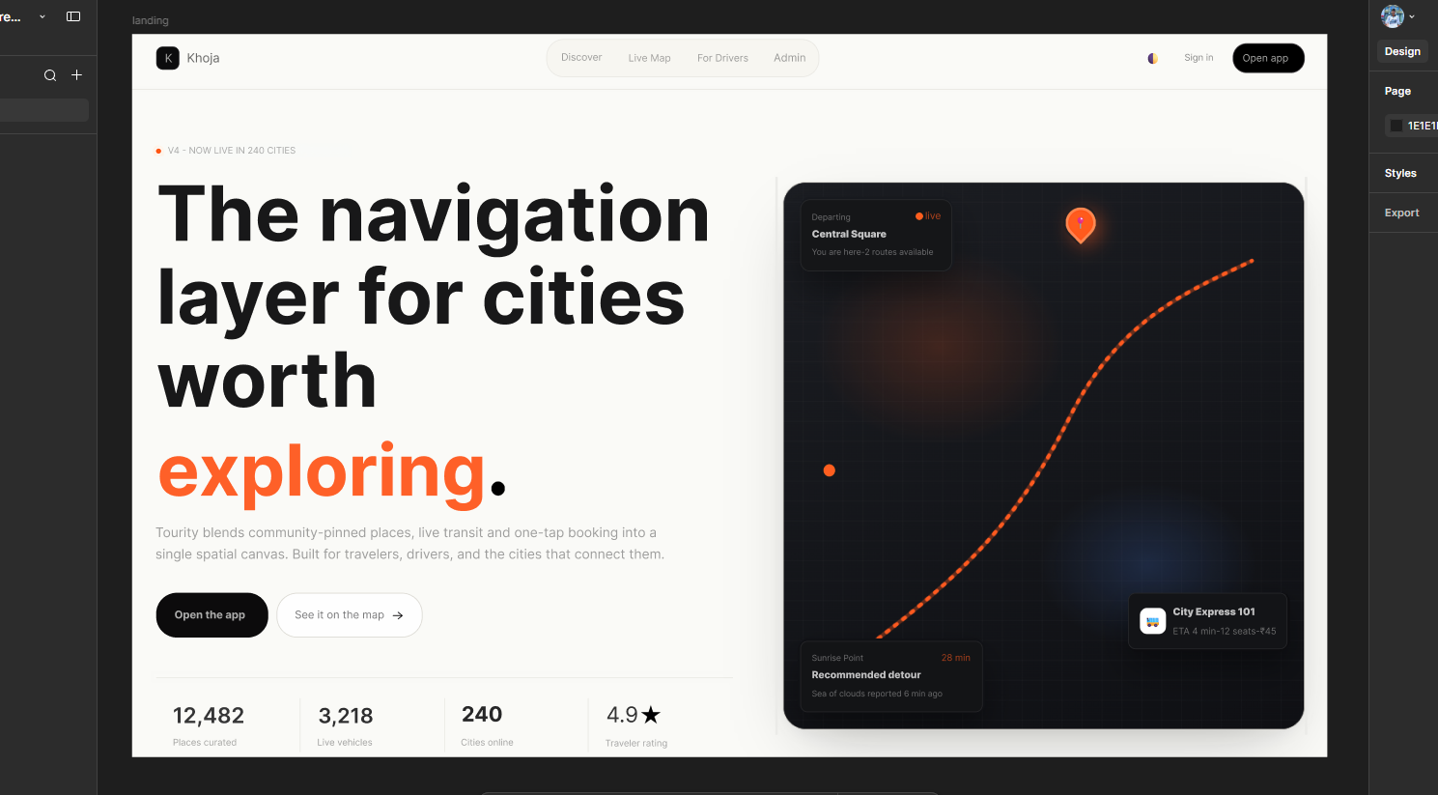
Figure 6.2: User’s Dashboard
- Discover Places
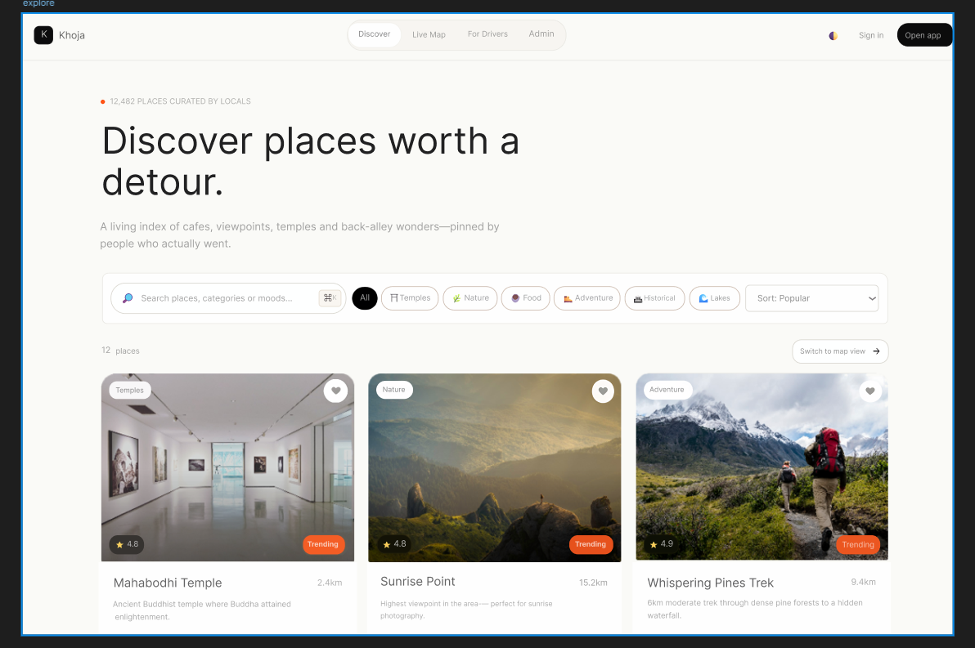
Figure 6.3: Discover Page

Chapter 7: References

[1] | L. Hill, "Leaflet: An Open-Source JavaScript Library for Interactive Maps," Leaflet Documentation, 2024.
[2] | OpenStreetMap. Foundation, "OpenStreetMap: Collaborative Mapping and Geographic Data Platform," OSM Technical Wiki, 2023.
[3] | Uber. Technologies, "Google Maps Platform: APIs for Location and Mapping Services," Google Developers Documentation, 2024.
[4] | TripAdvisor Inc. , "User Review Systems and Travel Recommendation Engine," TripAdvisor Technical Overview, 2023.

